Adviser Toolkit: eDM and LinkedIn assets
Module 1, 12.08.25

This toolkit provides copy and images for eDM and social posts that can be used by our network of accredited advisers, to promote their partnership with PPS Mutual.

We’ve provided assets for three topics that could cover be used through the August-September launch period:

- With a focus on our Launch
- With a focus on our specialism with professionals
- With a focus on our mutuality point of difference

In this toolkit doc, for each topic, you’ll find a mock-up and copy for:

- Long-form content for adviser ‘standalone’ eDM
- Short snippet of content for adviser ‘newsletter’ eDM
- Social post content focused on LinkedIn

Images are provided separately for download at Resources | PPS Mutual Adviser Hub

For each topic, there are three images available:

- 1:1 ‘moving’ image to use in social (ie GIF format)
- 1:1 ‘static’ image to use in social (ie JPG format)
- A landscape-oriented image to use in eDMs (ie JPG format)

Disclaimer
The content below has been made available to help you promote your relationship with PPS Mutual. Please do not make any alterations to PPS Mutual’s logos or other trade marks.

All content has been checked for accuracy as at the date of this email. If we provide updated content to you, please cease any further use of this content. Any omission or alteration of this content or ongoing use of any superceded content is at your own risk.

This content should not be used as the basis for any financial advice. For further information about PPS Mutual’s insurance cover and Profit Share Benefit (PSB), please refer to our product guides, policy wordings, PSB information sheet and other information available in the Adviser Hub.
Topic 1: Launch Focus.
Element: Standalone eDM

Mock-up: Copy to cut and paste:

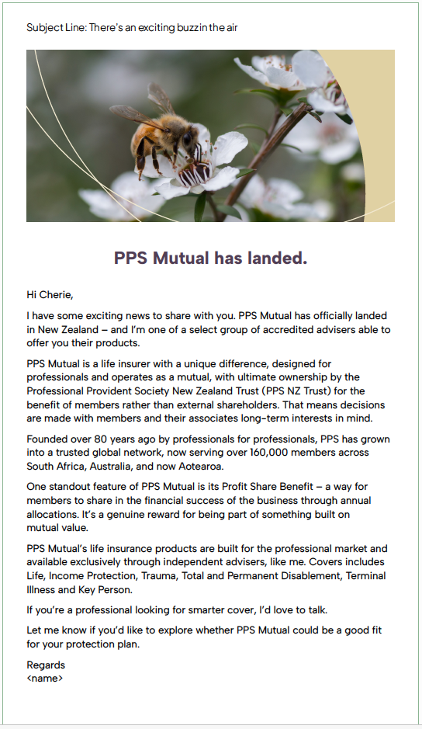
Subject Line: There’s an exciting buzz in the air
PPS Mutual has landed.

Hi <name>,

I have some exciting news to share with you. PPS Mutual has officially landed in New Zealand – and I’m one of a select group of accredited advisers able to offer you their products.

PPS Mutual is a life insurer with a unique difference, designed for professionals and operating as a mutual, with ultimate ownership by the Professional Provident Society New Zealand Trust (PPS NZ Trust) for the benefit of members rather than external shareholders. That means decisions are made with members’ and their associates’ long-term interests in mind.

Founded over 80 years ago by professionals for professionals, PPS has grown into a trusted global network, now serving over 160,000 members across South Africa, Australia, and now New Zealand.

One standout feature of PPS Mutual is its Profit Share Benefit – a way for members to share in the financial success of the business through annual allocations. It’s a genuine reward for being part of something built on mutual value.

PPS Mutual’s life insurance products are built for the professional market and available exclusively through independent advisers, like me. Covers includes Life, Income Protection, Trauma, Total and Permanent Disablement, Terminal Illness and Key Person.

If you’re a professional looking for smarter cover, I’d love to talk.

Let me know if you’d like to explore whether PPS Mutual could be a good fit for your protection plan.

Regards <name>

Alt subject lines as options:
Subject Line: When protection and purpose work together
Subject Line: Insurance with mutual benefits
Subject Line: Mutuality is the best policy

Image name when downloading:
Bee static image for Launch - eDM 1500x700

Topic 1: Launch Focus.
Element: eDM newsletter section

Mock-up: Copy to cut and paste:

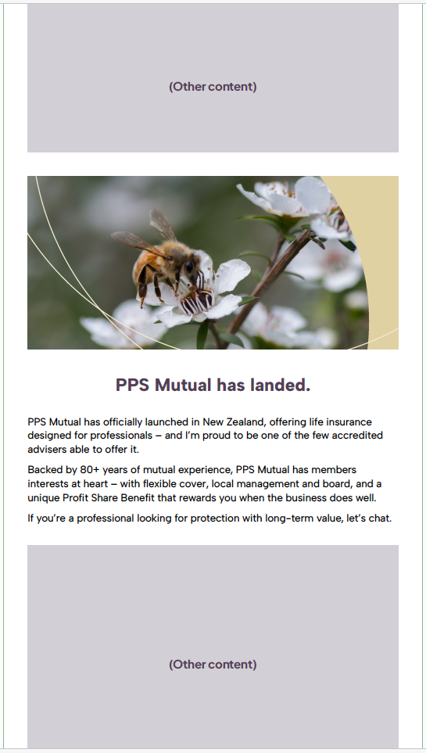
PPS Mutual has landed.
PPS Mutual has officially launched in New Zealand, offering life insurance designed for professionals – and I’m proud to be one of the few accredited advisers able to offer it.
Backed by 80+ years of mutual experience, PPS Mutual has members’ interests at heart – with flexible cover, local management and board, and a unique Profit Share Benefit that rewards you when the business does well.
If you’re a professional looking for protection with long-term value, let’s chat.

Image name when downloading:
Bee static image for Launch - eDM 1500x700
(Same image as per Standalone eDM)

Topic 1: Launch Focus.
Element: Social post

Mock-up: Copy to cut and paste:

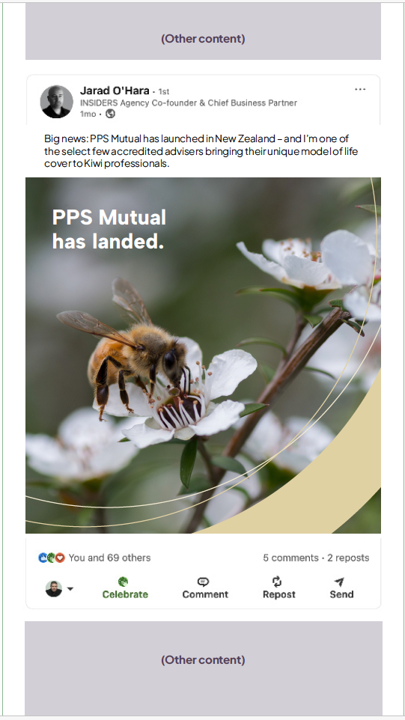
Big news: PPS Mutual has launched in New Zealand – and I’m one of the select few accredited advisers bringing their unique model of life cover to Kiwi professionals.

PPS Mutual is different. It’s a mutual, meaning it’s owned by a trust for the benefit of its members – not shareholders. That changes everything.

- Designed specifically for professionals
- Flexible, adviser-led cover
- Local management and board
- And a Profit Share Benefit that lets members share in the business’s success

If you’re a professional looking for protection that’s purpose-built for you I’d love to chat.
#LifeInsurance #Mutuality #PPSMutual #FinancialAdvice #NZProfessionals #ProfitShare

Image name when downloading:
Bee moving image for Launch - social 1x1.gif
Bee static image for Launch - social 1x1.jpg

Topic 2: Mutual Focus.
Element: Standalone eDM

Mock-up: Copy to cut and paste:

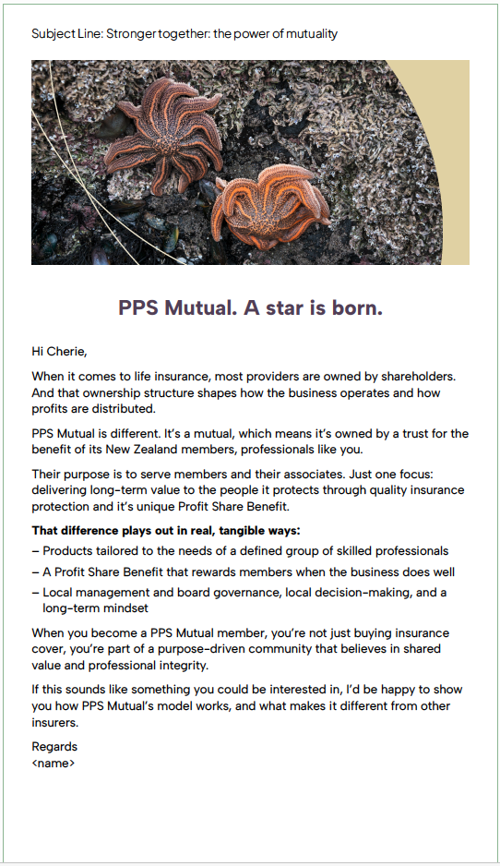
Subject Line: Stronger together: the power of mutuality
PPS Mutual. A star is born.

Hi <name>,

When it comes to life insurance, most providers are owned by external shareholders. And that ownership structure shapes how the business operates and how profits are distributed.

PPS Mutual is different. It’s a mutual, which means it’s owned by a trust for the benefit of its New Zealand members, professionals like you.

Their purpose is to serve members and their associates. Just one focus: delivering long-term value to the people it protects through quality insurance protection and its unique Profit Share Benefit.

That difference plays out in real, tangible ways:
– Products tailored to the needs of a defined group of skilled professionals
– A Profit Share Benefit that rewards members when the business does well
– Local management and board governance, local decision-making, and a long-term mindset

When you become a PPS Mutual member, you’re not just buying insurance cover, you’re part of a purpose-driven community that believes in shared value and professional integrity.

If this sounds like something you could be interested in, I’d be happy to show you how PPS Mutual’s model works, and what makes it different from other insurers.

Regards <name>

Alt subject lines as options:
Subject Line: Side by side: A better way to insure
Subject Line: Mutuality: It’s in our nature
Subject Line: Together through every tide

Image name when downloading:
Starfish static image for Mutual - eDM 1500x700

Topic 2: Mutual Focus.
Element: eDM newsletter section

Mock-up: Copy to cut and paste:

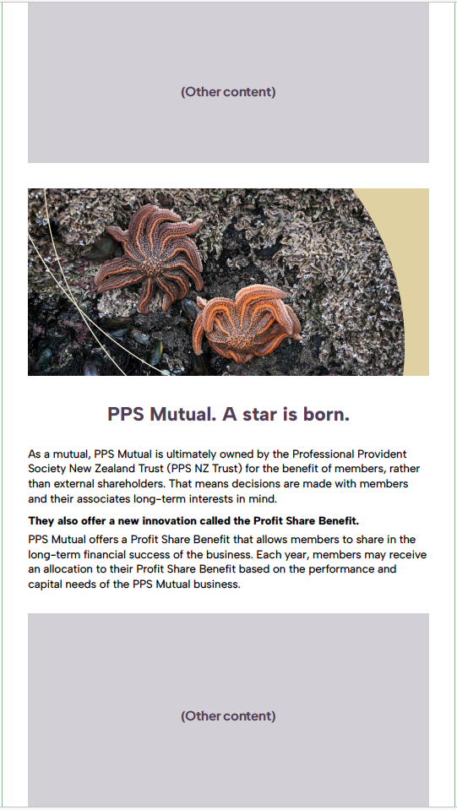
PPS Mutual. A star is born
As a mutual, PPS Mutual is ultimately owned by the Professional Provident Society New Zealand Trust (PPS NZ Trust) for the benefit of members, rather than external shareholders. That means decisions are made with members’ and their associates’ long-term interests in mind.

They also offer a new proposition called the Profit Share Benefit.
PPS Mutual offers a Profit Share Benefit that allows members to share in the long-term financial success of the business. Each year, members may receive an allocation to their Profit Share Benefit based on the performance and capital needs of the PPS Mutual business.

Image name when downloading:
Starfish static image for Mutual - eDM 1500x700
(Same image as per Standalone eDM)

Topic 2: Mutual Focus.
Element: Social post

Mock-up: Copy to cut and paste:

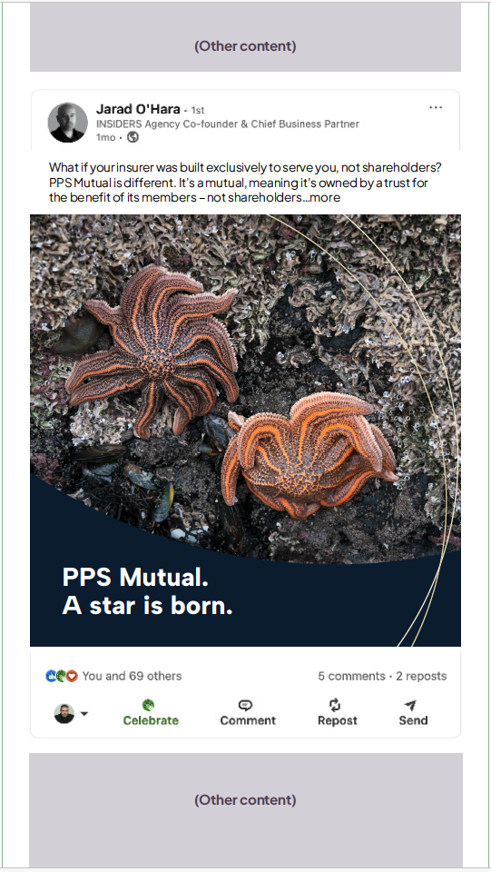
What if your insurer was built exclusively to serve you, not shareholders?

PPS Mutual is different. It’s a mutual, meaning it’s owned by a trust for the benefit of its members – not shareholders. That changes everything.

– Products designed exclusively for skilled professionals
– A long-term focus on member value
– The ability to share in the success of the business through the Profit Share Benefit

And I’m proud to be an accredited adviser offering PPS Mutual to professionals here in New Zealand.

If you value long-term thinking and real ownership, I’d love to talk.

#Mutuality #PPSMutual #NZProfessionals #LifeInsurance #FinancialAdvice #ProfitShare #IFA

Image name when downloading:
Starfish moving image for Mutual - social 1x1.gif
Starfish static image for Mutual - social 1x1.jpg

Topic 3: Professional Focus.
Element: Standalone eDM

Mock-up: Copy to cut and paste:

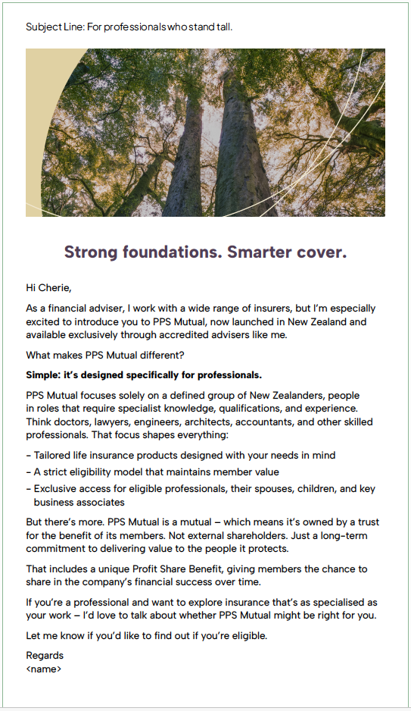
Strong foundations. Smarter cover.

Hi <name>,

As a financial adviser, I work with a wide range of insurers, but I’m especially excited to introduce you to PPS Mutual, now launched in New Zealand and available exclusively through accredited advisers like me.

What makes PPS Mutual different?

Simple: it’s designed specifically for professionals.

PPS Mutual focuses solely on a defined group of New Zealanders, people in roles that require specialist knowledge, qualifications, and experience. Think doctors, lawyers, engineers, architects, accountants, and other skilled professionals. That focus shapes everything:
- Tailored life insurance products designed with your needs in mind
- A strict eligibility model that maintains member value
- Exclusive access for eligible professionals, their spouses, children, and key business associates

But there’s more. PPS Mutual is a mutual – which means it’s owned by a trust for the benefit of its members. Not external shareholders. Just a long-term commitment to delivering value to the people it protects.

That includes a unique Profit Share Benefit, giving members the chance to share in the company’s financial success over time.

If you’re a professional and want to explore insurance that’s as specialised as your work – I’d love to talk about whether PPS Mutual might be right for you.

Let me know if you’d like to find out if you’re eligible.

Regards <name>

Alt subject lines as options:
Subject Line: Protection that grows with you.
Subject Line: Strength. Stability. Specially made for you.

Image name when downloading:
Trees static image for Professional - eDM 1500x700

Topic 3: Professional Focus.
Element: eDM newsletter section

Mock-up: Copy to cut and paste:

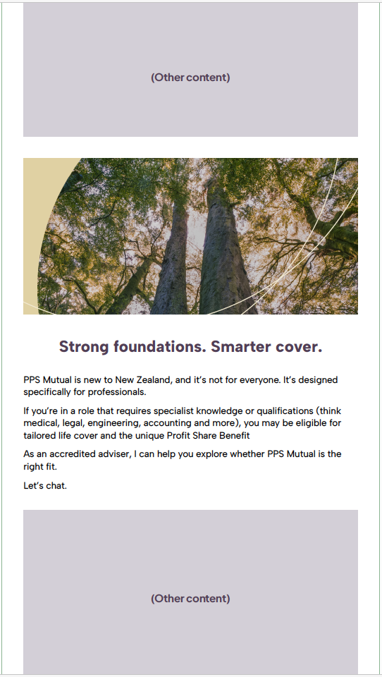
Strong foundations. Smarter cover.
PPS Mutual is new to New Zealand, and it’s not for everyone. It’s designed specifically for professionals.
If you’re in a role that requires specialist knowledge or qualifications (think medical, legal, engineering, accounting and more), you may be eligible for tailored life cover and the unique Profit Share Benefit
As an accredited adviser, I can help you explore whether PPS Mutual is the right fit.
Let’s chat.

Image name when downloading:
Trees static image for Professional - eDM 1500x700
(Same image as per Standalone eDM)

Topic 3: Professional Focus.
Element: Social post

Mock-up: Copy to cut and paste:

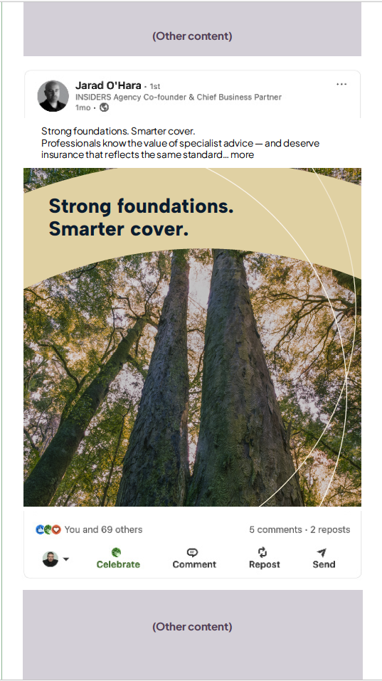
Strong foundations. Smarter cover.
Professionals know the value of specialist advice — and deserve insurance that reflects the same standard.

That’s why I’m proud to be accredited to offer PPS Mutual, a new life insurer in New Zealand designed specifically for professionals.

Only a select group of eligible professionals (and their families or business partners) can access PPS Mutual. That exclusivity allows the product to be tailored, flexible, and deeply aligned with professional lives.

It’s also a mutual, which means:
- You’re not just a customer — you’re a member
- Decisions are made with long-term member value in mind
- You may be eligible for the Profit Share Benefit which can provide you the chance to share in PPS Mutual financial success over time.

If you’re a professional looking for smarter protection, I’d love to help you explore if PPS Mutual could be a fit.

#PPSMutual #NZProfessionals #LifeInsurance #Mutuality #ProfitShare #FinancialAdvice #IFA #ProfessionalProtection

Image name when downloading:
Trees moving image for Professional - social 1x1.gif
Trees static image for Professional - social 1x1.jpg

